**System Role**

1. **List Page:** Shows all added user in list page

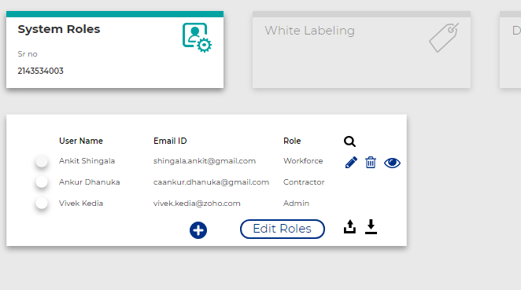

* Add Tenant selection (drop down)
* In list page add one column for Edit role.
* Remove Edit role button.
* Remove row selection
* On click on delete icon show confirmation

1. **On Add / Edit role**

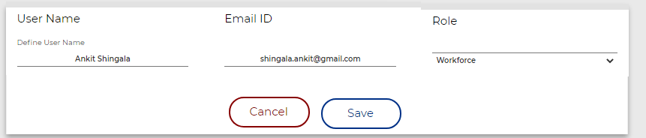

1. **On Edit role open given page**

* Provide 4 tab for Masters, Modules, Reports, StatutoryReport
* Add row level and column level check box for give permission
* Add checkbox for select all check box in given section. Like master checkbox selected then all items inside masters are checked automatically.

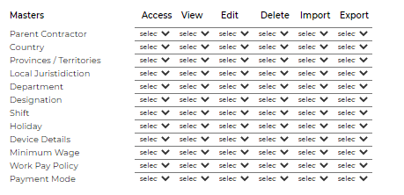

4. **Create mail template for reset password**

Once user with role is created, mail is send to respected user and they can set their password.

**Admin panel - Default group permission**